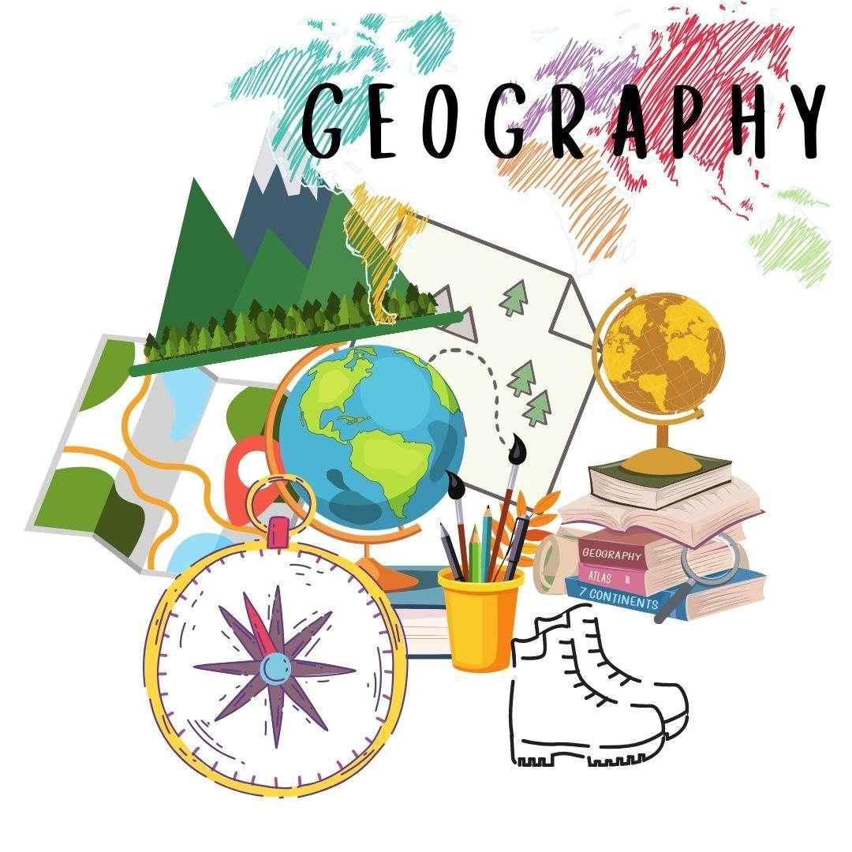
Tropical Rainforest
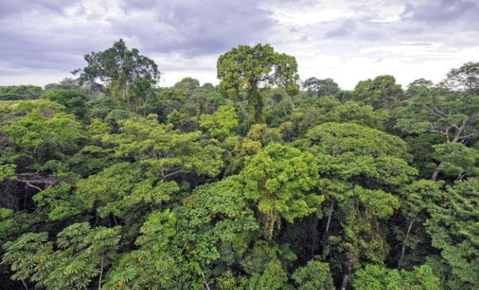

A Rainforest is a place of tall, green trees and receives lots of rainfall .

The trees in the Rainforest are so thick that the ground receives very less sunlight.

Rainforest has lots of trees that form a thick canopy and that is why it is very dark in a

rainforest.

The Amazon rainforest is the world’s largest rainforest.

The world’s largest waterfall- the Santo Angel is in the Amazon rainforest.
Some animals and birds found in Tropical _{Toucan rainforests.}
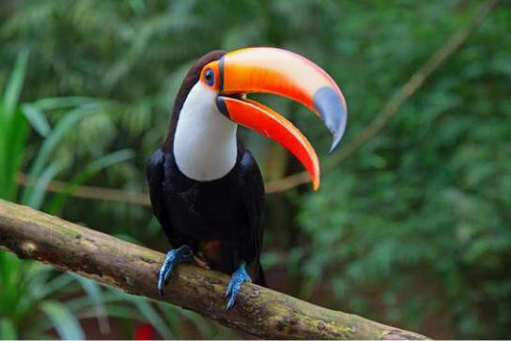

Toucans have a black body and a white or yellow throat.

They have large, colorful beaks called bills.

They have small wings and are not very good at flying.

Toucans spend a lot of their time in trees.

They live in tree holes that are naturally found in trees or that have been made by other birds.

Toucan are omnivorous. They eat fruits, insects, frogs, and eggs of other birds.

A baby Toucan is called a chick.

A group of toucans is called a flock.
Tree frog
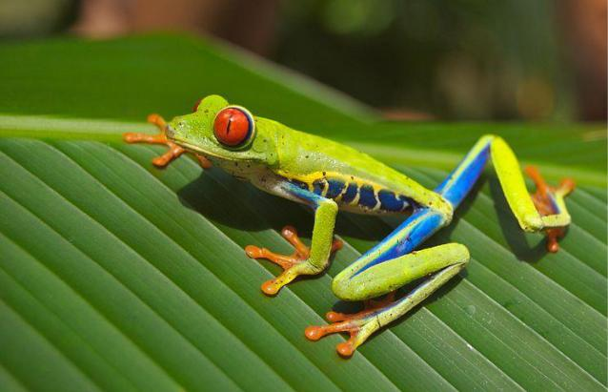

Have you ever seen a picture f a little green frog with big, red eyes? This is
the tree frog that lives in the rainforest..

A tree frog spends most of its life up in the trees

They have claw-shaped toes on their feet and sticky toe pads that allow

them to climb trees easily.

They are great jumpers.

They come in a variety of colors, most commonly green, grey, blue, yellow,

red, or brown.

It can change color. It blends color with the surroundings, so other animals

cannot identify it. This is called camouflage.

They are carnivores, they eat other animals.

They also eat insects such as flies, mosquitoes, moths and dragon flies.

They use their long and sticky tongues to catch the food.

A baby frog is called a tadpole.

Sound of the frog: croak.
They belong to the “ape” family | Orangutan
They spend most of their lives up in the tree’s.
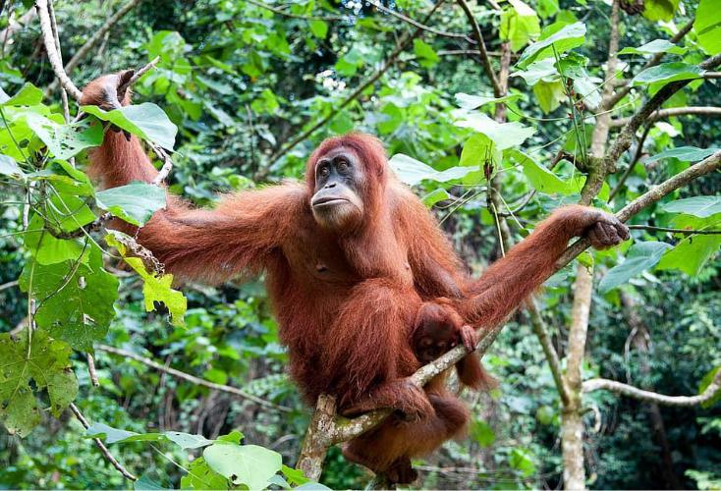

They have long, powerful arms and hook-shaped hands and feet.

Orangutans can climb and swing from tree to tree with ease.

They are red-haired and do not have tails.

On the grounds, orangutans walk on all fours.

They are very intelligent and make roofs with tree branches to keep

themselves dry during rain.

Orangutans are omnivorous. They eat fruit, flower, nuts, insects, and other

parts of plants and trees
As a result of people cutting down the trees {deforestation} the number

of orangutans has reduced. This makes them an endangered species.

Very few orangutans are left in the world.
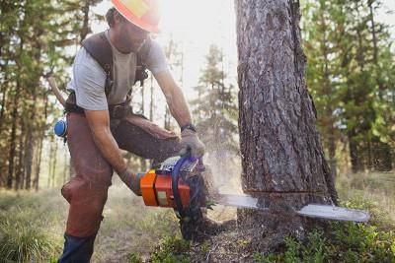

Orangutan

Why do you think the Orangutans will die without trees?

Activity 1:

Stick the pictures of animals found in the Tropical Rainforest.
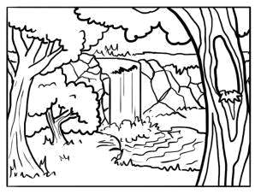
Activity 2 :

Color the Forest.

